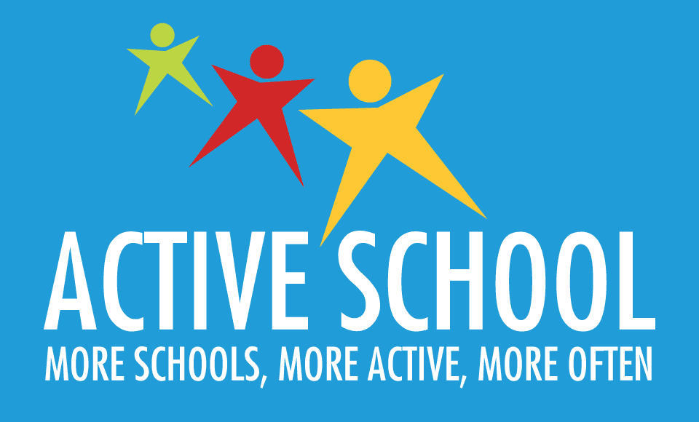
Feedback from our from our Parents’ Active School Survey:
Positives:
The majority of participants said that:
- Your child enjoys PE.
- You rate PE as a very important subject.
- Your child usually enjoys PE homework.
- Your child benefits from our school running initiatives.
- You think classroom physical activity breaks are of benefit to your child.
- Your child enjoys breaks in the playground.
- You are aware your child needs 60 minutes of physical activity each day.
- Lots of you are happy about our ‘Feel Good Fridays’ where children have the opportunity to dance to music on the yard.
- Lots of you are also pleased with our focus on an ‘active playground’ where children have the opportunity to play with skipping ropes, balls & hula hoops on yard as well as to participate in organised games on designated days.
- Our school has a positive approach towards physical activity.

Some areas we will work on:
- Ensuring you are given enough information about your child’s progress in PE
- Teachers will endeavour to ensure that students’ progress in PE is discussed at parent teacher meetings & that meaningful comments are given in end of year school reports regarding children’s progress in PE
- Some of you were unsure about whether we have adequate resources for teaching PE.

- We have recently completed an audit on the PE equipment we have and we have ordered new equipment that we feel will benefit the teaching of each PE strand. This includes goal posts for the field! Once this order is delivered, we will update you further on the specific resources we have available.
Notes:
- We are currently organising to have markings in the yard to facilitate traditional playground games such as hopscotch.
- We are aware of the importance of children having unstructured play time too so organised yard games are designated on specific days for each class.
- Skipping ropes, hula hoops & balls are provided on yard on your child’s ‘active yard day’ & playground leaders also organise & teach traditional playground games to younger children. Children are encouraged to take part.
- Children take part in ball games on the yard & sports/games in the field on designated days.
- Each strand in the PE curriculum is given equal teaching time throughout the school year. (Slight exception – aquatics/swimming which is currently facilitated from 1st-6th class. Junior classes are taught about hygiene & water safety.)
The six strands are: Dance, Athletics, Games, Gymnastics, Outdoor & Adventure & Aquatics.
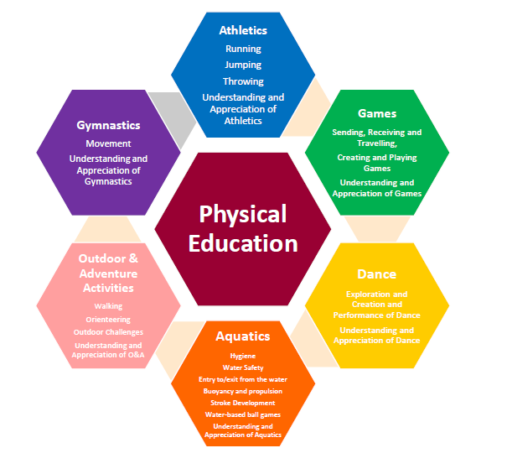
- We make a huge effort to encourage all children to be active in every way possible. We endeavour to reward effort and enthusiasm, while also acknowledging & celebrating children’s achievements. We want every child to have fun & play and to enjoy being active in every possible way!
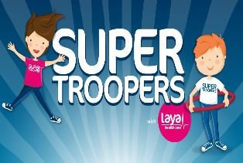
- Super Trooper homework journals: if your child completes another activity instead of these, that’s perfectly okay! If your child is able, they can write this activity in the journals instead (eg. Dance/GAA). We just want to encourage children to be extra active at home too! Please continue to sign the journal each week.
- You can check in on what we are doing by visiting the Active School section of our website!
- Thanks for all the great suggestions for our Active School Week! Thanks also to those of you who have volunteered to help out or come in & share your expertise. We will certainly reach out beforehand!
Thanks,
The Active School Team

