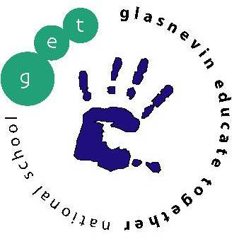
Glasnevin Educate Together National School,
Griffith Avenue, Glasnevin, Dublin 11
01-8572086
scoilgetns@gmail.com
www.get.ie

Third Class Booklist 2019/2020

Please note school opens on Monday 2nd September
All copies, folders to be labelled at the FRONT please
- 2 x Handwriting Copy AS x B4
- 4 x Squared Maths Copies (7mm squares)
- 7 x 88 Page Copies
- 3 x A4 Hardback Copies
- 5 x A4 Plastic Document Wallets
- 1 x scrapbook (larger than A4)
- Deck of playing cards
- 1 glue stick, colouring pencils, ruler, 2 x pencils, rubber, parer, blue/black pens, 2 x red pen, 3 x whiteboard marker.

As we are a green school, we would encourage parents to invest in a reusable water bottle to help reduce single use plastic.

Parents, in order to cut down costs for you, please be aware, that the school has invested in books. This is why you may notice that the booklist is somewhat reduced.

Voluntary Contribution
Book Loan Voluntary Contribution Scheme: €15.00
Sundries: Voluntary Contribution for paper, photocopying (€30),
Art & Craft Materials (€30), Personal Insurance (€10) €70.00
School Diary €5.00

Please send in total amount of €90 in an envelope with your child’s name on it. If you have contributed €250 in the calendar year January – December 2019, you need not pay the above amounts.

Please have all required copies and equipment for the first day of school which will be Monday 2nd September 2019

* Parents please note if you have more than one child in the school, there is a sliding scale for these voluntary contributions: 1st Child €85, 2nd Child €60, 3rd Child €35.

