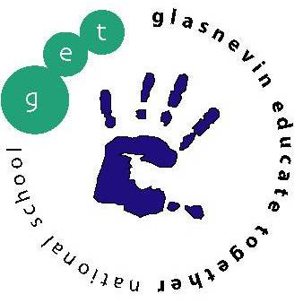
Glasnevin Educate Together National School,
Griffith Avenue, Glasnevin, Dublin 11
01-8572086
scoilgetns@gmail.com
www.get.ie
JUNIOR INFANTS BOOKLIST 2019/2020
Please note school opens on Monday 2nd September and children will go home at 12 noon for the first two weeks,
All copies, folders to be labelled at the FRONT please
4 x Blank Practice Copy Books (Copybook with blank pages)
4 x Project Copy Books (Top blank, bottom extra wide ruled) (i.e. ASXP15)
4 x Junior Sums Copies –20mm squares
1 x A4 Envelope Plastic Wallets
1 x A3 Plastic wallet
4 x Triangular pencils (for classroom work)
3 x whiteboard markers
3x Glue sticks (Clear, not coloured)

For School:

Spare set of clothes in a plastic bag in case of toilet ‘accidents’, labelled please.
As we are a green school we would encourage parents to invest in a reusable water bottle to help reduce single use plastic.

At Home:
Access to colours (crayons or colouring pencils), triangular pencils.

Children will only need a small school bag with just enough room for a copy and a lunch box (no wheels on bag please).

Please have all required copies and junior grip pencils for the first day of school

All copies, materials and clothes should be labelled with child’s name.

Children in Junior Infants will go home at 12 noon from Monday 2nd September until Friday 13th September. School starts at 8:40 each day but on the first day you might like to arrive a little later. Normal finishing time (1:20) will begin on Monday 16th September.

