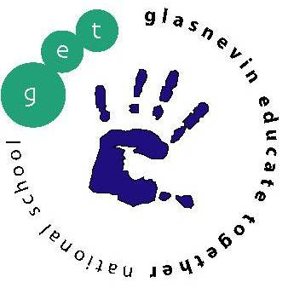
Glasnevin Educate Together National School,
Griffith Avenue, Glasnevin, Dublin 11
01-8572086
scoilgetns@gmail.com
www.get.ie

First Class Booklist 2019/2020

Please note school opens on Monday 2nd September
All copies, folders to be labelled at the FRONT please

Copies: 1 X A4 Hardback Copies
2 x Maths Copies (10 mm sq),
8 x Project Copies (15a),
3 x Learn to Write B4 copy,
1 x Spelling Notebook A5,
1 x A3 plastic mesh zip wallet
1 x A4 Plastic Folder,
2 x A4 paper folders.

Your child will also need a pencil case with: pencils, colouring pencils, ruler, rubber, parer and glue stick.

As we are a green school, we would encourage parents to invest in a reusable water bottle to help reduce single use plastic.

Parents, in order to cut down costs for you, please be aware, that the school has invested in books. This is why you may notice that the booklist is somewhat reduced.

Voluntary Contribution
Book Loan Voluntary Contribution Scheme: €15.00
Sundries: Voluntary Contribution for paper, photocopying (€30),
Art & Craft Materials (€30), Personal Insurance (€10) €70.00
School Diary €5.00

Please send in total amount of €90 in an envelope with your child’s name on it. If you have contributed €250 in the calendar year January – December 2019, you need not pay the above amounts.

Please have all required copies and equipment for the first day of school which will be Monday 2nd September 2019

* Parents please note if you have more than one child in the school, there is a sliding scale for these voluntary contributions: 1st Child €85, 2nd Child €60, 3rd Child €35.

